Part 2

**Alyce Marketing Analytics**

**About the Dataset:**

* AlyceClientCompany - This is a dimension table which contains information about the Alyce's clients.
* AlyceGiftData - This is a dimension table which contains information about different types of gifts
* Services - This is a dimension table which contains information about different types of services offered by Alyce like one-to-one gifting, swag select etc.
* AlyceRecipientData - This is a dimension table which contains information about the gifts sent by the Alyce's client to the people who they want to maintain relationship with.
* AlyceClientExpenditure - This table holds the information about the type of gift, recipient to which the client sent the gift and also few metrics like price, quantity etc.
* AlyceFact - has information about the total amount spent by alyce's client

**Marketing Analytics**

**Problem Statement:**

**On** analyzing the data the biggest problem, we noticed that the purchasing pattern by regions were different from our own dataset. After working on eCommerce dataset, Alyce had a catalog of basic products whose price ranges from $44-99.

      From the **order status**, we can see that a lot of the orders are ‘Rejected’ or are ‘in-Progress’, it shows that conversion rate is not more than 50%.

From the **promotions chart**, we can see that the 3rd Promotion is working the best out of the three promotions applied and the sales of promotions for Chocolates and the Engraved Metal Pens is the bed.

The **Quantity by State** chart shows that the sales is not consistent in all the regions of the US, the quantity and the sales of products are the best in Florida and Texas.

Conclusion:

For sales in every region to be consistent, and for the client to have a better experience we can come up with a better marketing strategy in the future by understanding the behavior of the customer by segmenting them into different personas and tracking their purchasing conduct and see where the customer interest’s lie. We can also promote the service through social media platform to attract new customers.

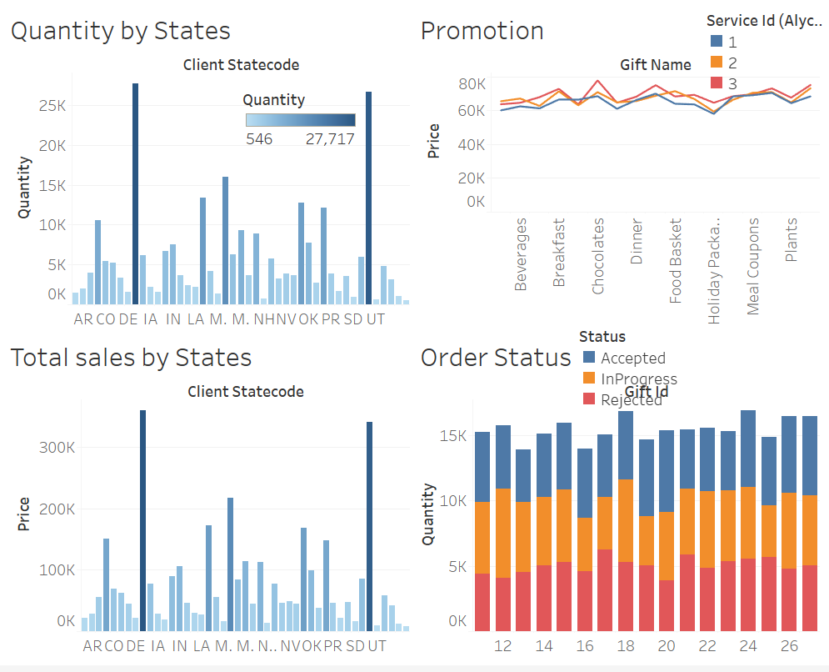

Team Members:

Anisha Ganguly

Xiaoying Shi

Ruta Lad